**Project Title:**

**🏛️ Harvard’s Artifacts Collection: ETL, SQL Analytics & Streamlit Showcase**

**Domain: Cultural Heritage Data Analytics / Museum Informatics**

**Feature:**

* Collected a minimum of 2500 records for each chosen classification(via streamlit) using the API.
* Stored these records in 3 separate SQL tables for further querying and analysis.

**Software used:**

Language : python, SQL

Tools : Jupyter notebook, MYSQL work bench

UI :  Streamlit dashboard

**Skills take away From This Project :**

* API Integration & Data Extraction
* Data Transformation (ETL)
* Streamlit App Development
* SQL Table Design & Data Insertion
* Interactive Data Exploration

**Steps:**

* Getting the Harvard Art Museums API Key
* Once Api key collected checked the classification details.
* The Harvard Art Museums API offers a rich collection of artifacts categorized under *116* unique classifications — ranging from *Paintings*, *Sculptures*, and *Coins* to *Jewelry*, *Furniture*, *Drawings*, and many more. These classifications represent different types of artworks and historical objects preserved in the museum's digital archive.

API_KEY = "d6eb908a-e375-4aa7-a997-db5cc795535d"

url = "https://api.harvardartmuseums.org/classification"

import requests

params = {

"apikey":API_KEY,

"size":100 }

response = requests.get(url,params)

response

* Below are the python queries we used

!pip install requests

import pandas as pd

* Once classification details gathered we took a minimum of 2500 records for each chosen classification.

**SQL Parts :**

* Using mysql we created a Database – **harvards_db**
* Then created 3 tables named

**artifact_metadata**

**artifact_media**

**artifact_colors**

* Once table created we inserted data from classification with help of mysql connection by cursor
* Created 20 queries and display the output in steamlit application
* After inserted data we moved to steamlit using

pip install streamlit streamlit-option-menu

pip install streamlit streamlit

above comments

* then, created py files

**App Interface Layout**

* + Title + Instruction
  + Dropdown to select a classification(Ex: Coins, paintings, scriptures, jewellery,Drawings etc..)
  + Collect a minimum of 2500 records for every classification.  
    Buttons
  + Collect Data → fetch from API
  + Show Data → display fetched records
  + Insert into SQL → store data into SQL table

Screenshot for the output:

1.

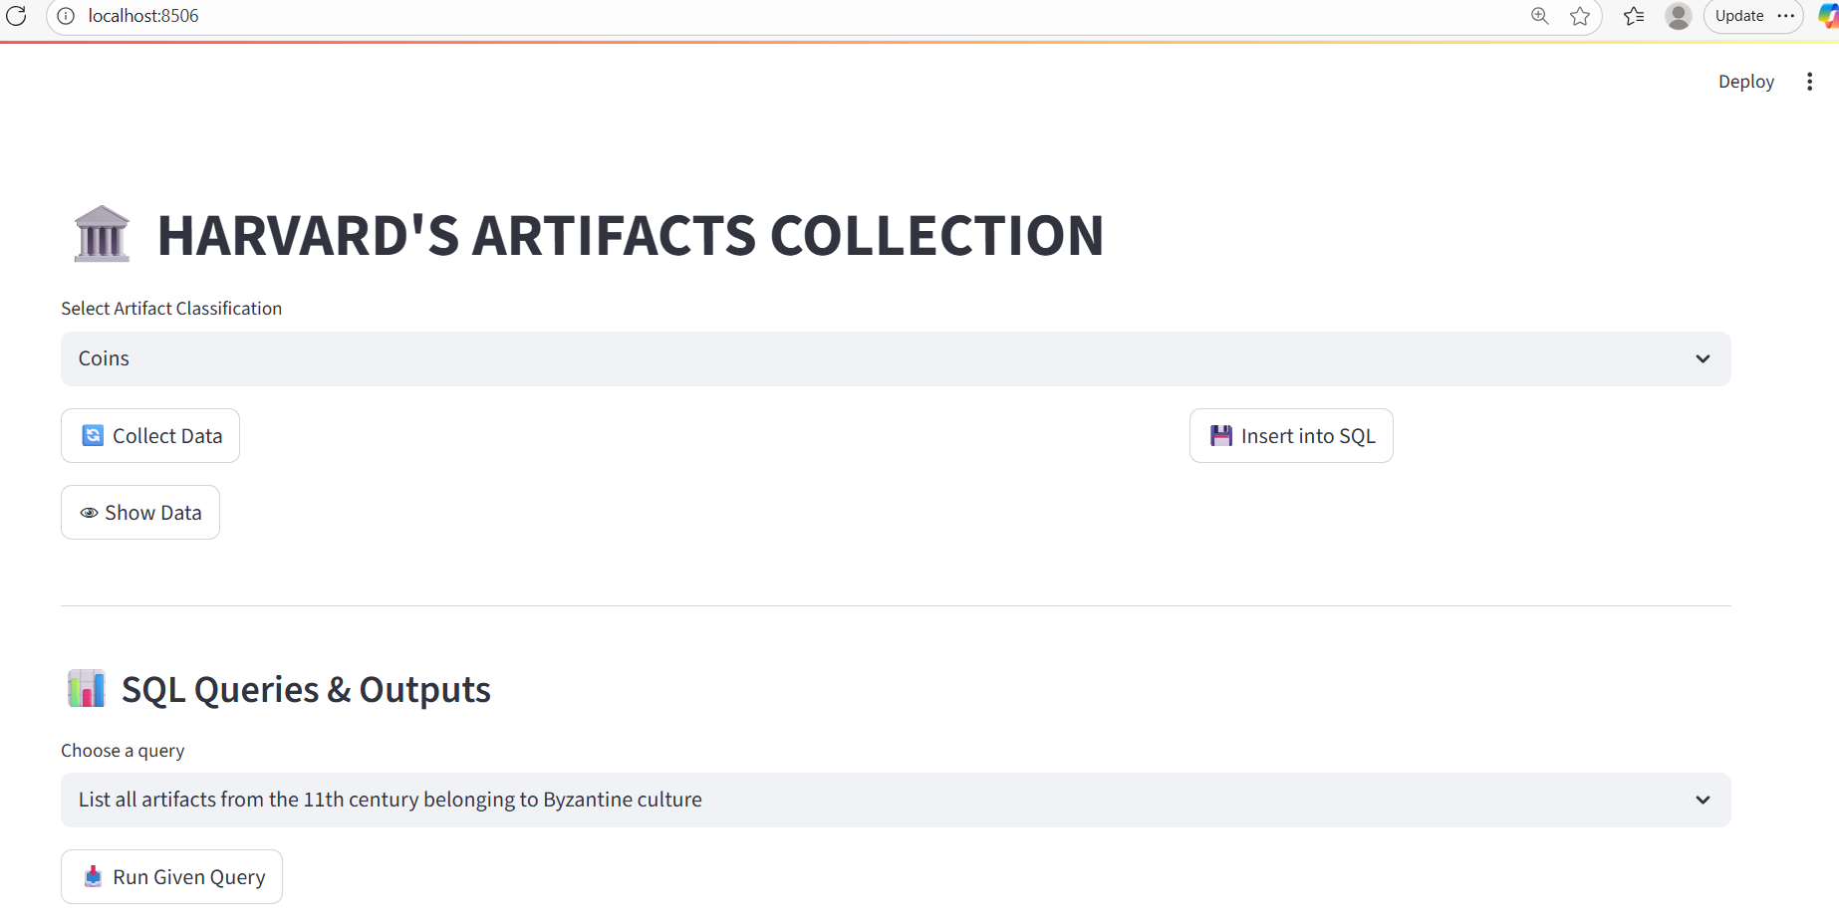

2. Choose one of the artifacts from the list and click collect data. It collects 2500 records.

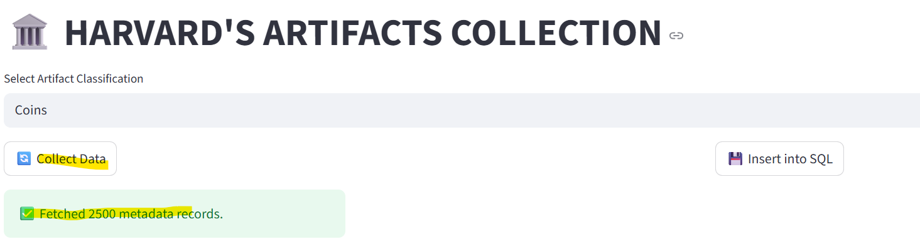

3.Show Data

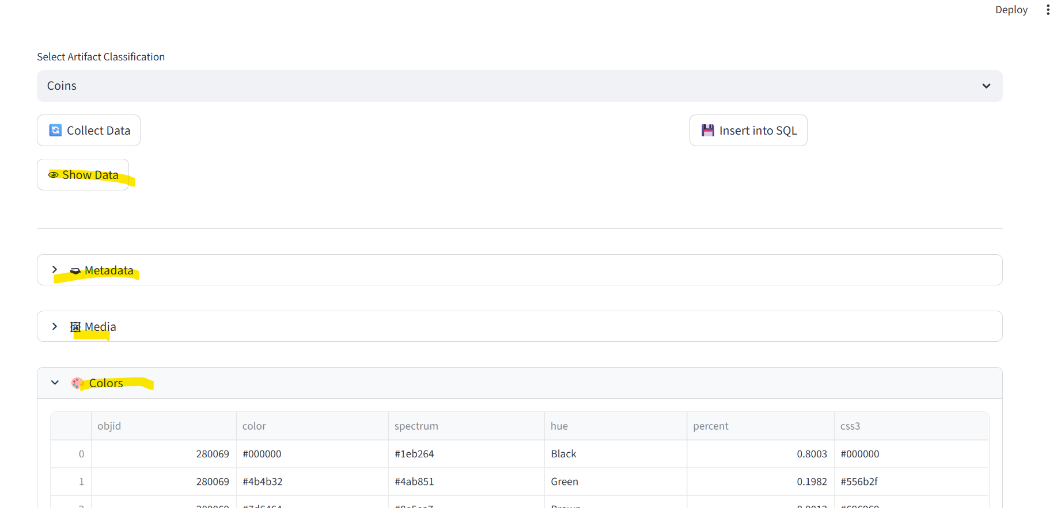

4. Insert into SQL

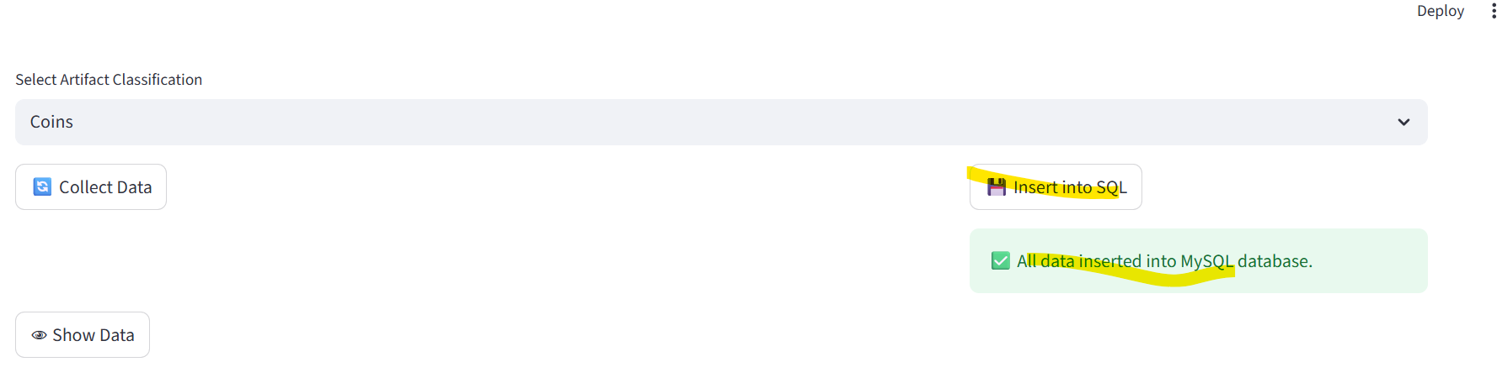

5. Choose any SQL query and Run Given Query.

